How to tell the difference between a male and a female betta

Method one: Fins and colors

A male betta will generally have longer, more colorful fins than a female betta will. A female’s fins will generally be short and drab. On the contrary, a male’s fins will be long, flowing and very colorful. Another way to tell is by the ventral fins which are two very slender fins located underneath their bellies. A full grown male’s ventral fins will generally be longer than his anal fin, but a female’s ventral fins won’t go any longer than her anal fin. Please note that there is such thing as a short- finned male, so be careful that the fish you’re looking at isn’t what is known as a plakat betta, or a short- finned fish.

Method two: Egg spot

A female betta will have an egg spot on her stomach which is a small, white dot used to release eggs during spawning. A male can have an egg spot if he is a juvenile, however as he ages it will go away. The egg spot will become more noticeable as a female ages and reaches the point in her life when she can breed.

Method three: Beards

Bettas have a membrane beneath their gill plates that appears as if it is skin. This “skin” will only be visible in males. When a betta “flares”, or widens it’s fins and pushes out their gill plates to make them look bigger, the beard will be visible. When a female “flares,” her beard won’t be visible.

A male betta; notice the bright, long fins, no egg spot and the black “beard” underneath his gill plates.

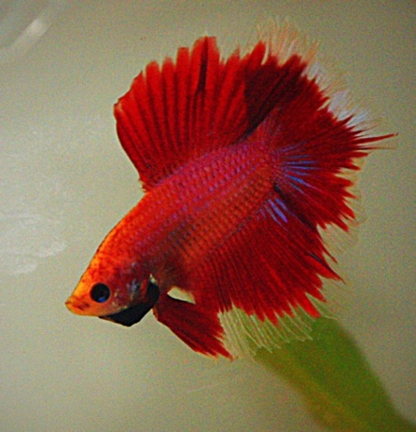

Some examples of female bettas; notice their drabber colors, smaller fins, egg spot between their ventral and her anal fins and no beard.

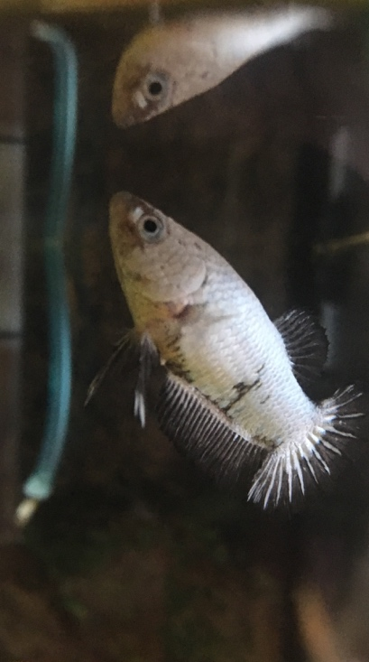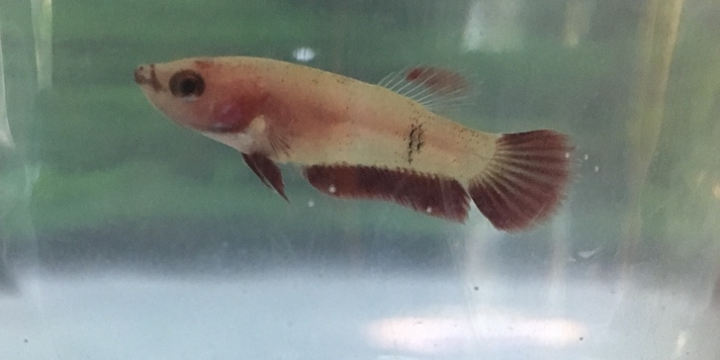

Beware of the plakat (short finned) male betta!! Pictured below are actually male bettas!!!

